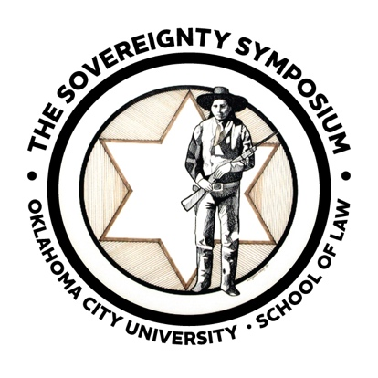
The Sovereignty Symposium XXXVII

June 12-13, 2025
OKANA Resort, Oklahoma City, OK

WRITING COMPETITIONS

HARGRAVE PRIZE FOR WRITINGS
By Past or Present Sovereignty Symposium Presenters or Attendees
Awards will be given in the amounts of $1,500, $1,000 and $750 for the best three original and previously unpublished papers. The winners will be included in the Symposium publication.

DOOLIN PRIZE FOR STUDENTS

This competition is open to any student enrolled in college, at any level. First, second and third prizes in the amounts of $1,000, $750 and $500 will be awarded. The winning entry will be published in the symposium publication. Second and third place entries will be published if space permits.

HAGER PRIZE

The Hager Prize of $1,000 will be awarded for the best writing, either student or presenter, on the ICWA or any legal issue concerning Native American children. The winning entry will also be published in the Symposium publication.

REQUIREMENTS

- The entries in the writing competitions must be fifty (50) single-spaced pages in length or less.
- The paper used shall be 8-1/2” x 11” in size.
- Use a 12-point font in Times New Roman format. The left and right margins must be 2”; the top and bottom margins must be 1.5”.
- The title of the paper, the name of the author and a current email, mailing address and telephone number must be placed on the cover page.
- Only the title of the paper should appear at the top of the first page of the text. The author’s name should appear on the cover page only.
- Papers must be submitted online via the website under the Attend/Competition tab at thesovereigntysymposium.com
- If you wish to Email the formatted version to sovereignty.symposium@okcu.edu as back up you may.

ALL PAPERS MUST BE SUBMITTED NO LATER THAN MARCH 24, 2025.
Winners will be announced by April 8th.
If you have any questions, call Lori Harless at (405) 208-5017.

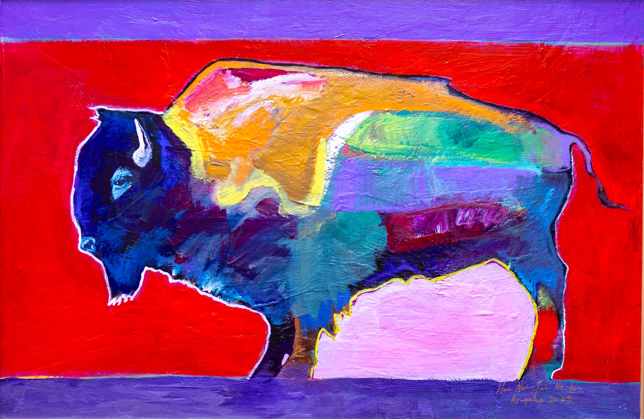
“Love” by Brent Learned, 2024 Sovereignty Symposium artist

